How to change your password

Please log into your Patient Access account.

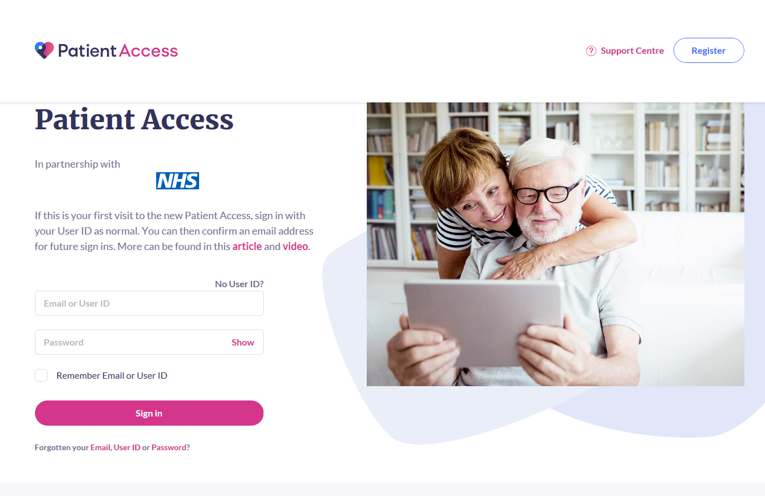

If you would like to change your password you can do this by clicking on the arrow next to your name in the top right hand corner of the screen and selecting View Profile.

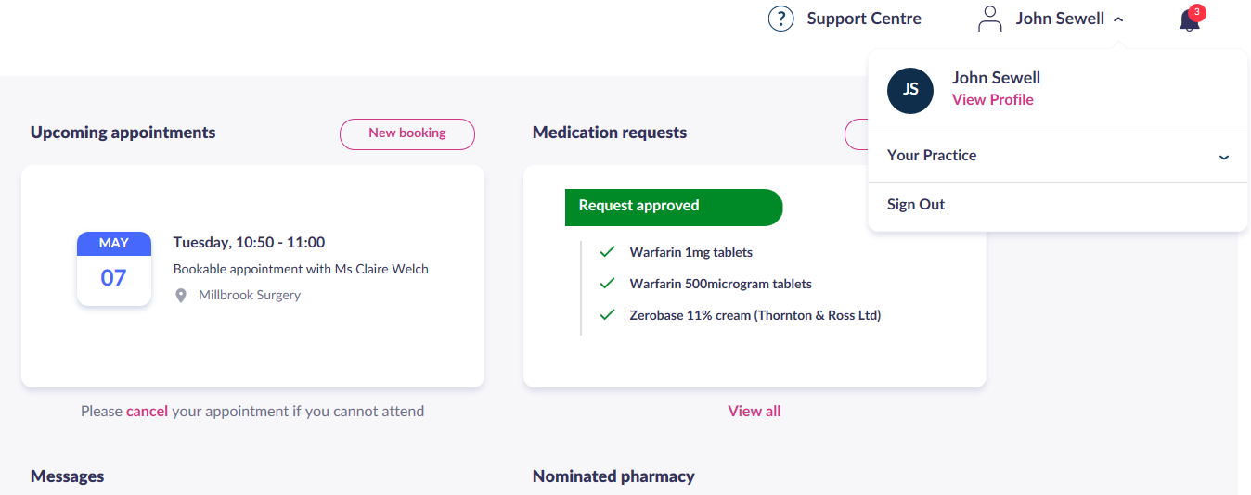

Click on Change password and follow instructions on the screen.

